Graph Theory project 2020

Thompsons Construction



Grace Keane – G00359990

BSc in Computing in Software Development

Introduction

Thompsons construction is a method of transforming a regular expression into an equivalent nondeterministic finite automaton (NFA). NFAs can be used to match strings against the regular expression. The algorithm works by splitting an expression into its constituent subexpressions. This algorithm is created by a computer scientist called Kem Thompson.

Numerous rules apply to this algorithm for it to work properly. Rules are listed below.

The empty-expression ε is converted to



A symbol a of the alphabet is converted to

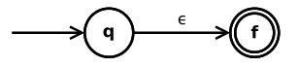

The union expression s|t is converted to

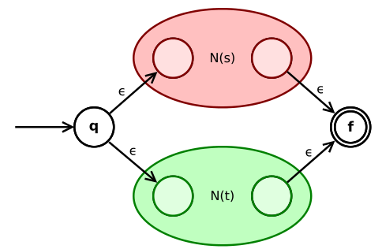

The concatenation expression st is converted to

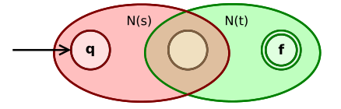

The Kleene star s* is converted to

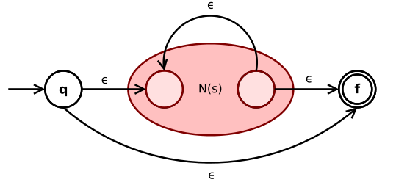

References for Graph Theory project 2020

Thompson's construction

[1] https://en.wikipedia.org/wiki/Thompson%27s_construction